Lab report

Khrystian Clark (CLARKKHR)

ONID: 933-953-264

Part 1:

1. What is the current value (in Hex) of the EAX Register?
   * FFFFFFFF (the first item in the first row of the registers screen)
2. What is the current state (Set/Clear) of the following flags: Carry, Overflow, Zero, Sign?
   * All flags are in the current state of 0 (The items circled in the second row of the registers screen)

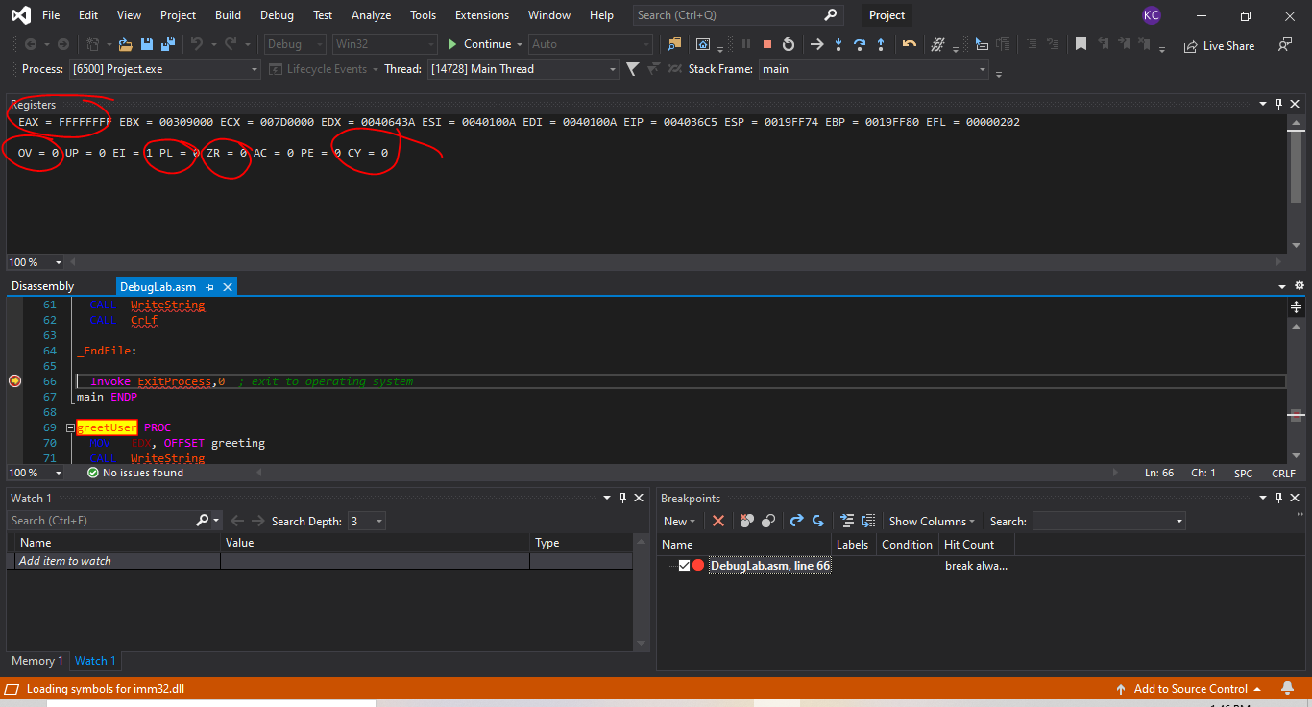

Part 2: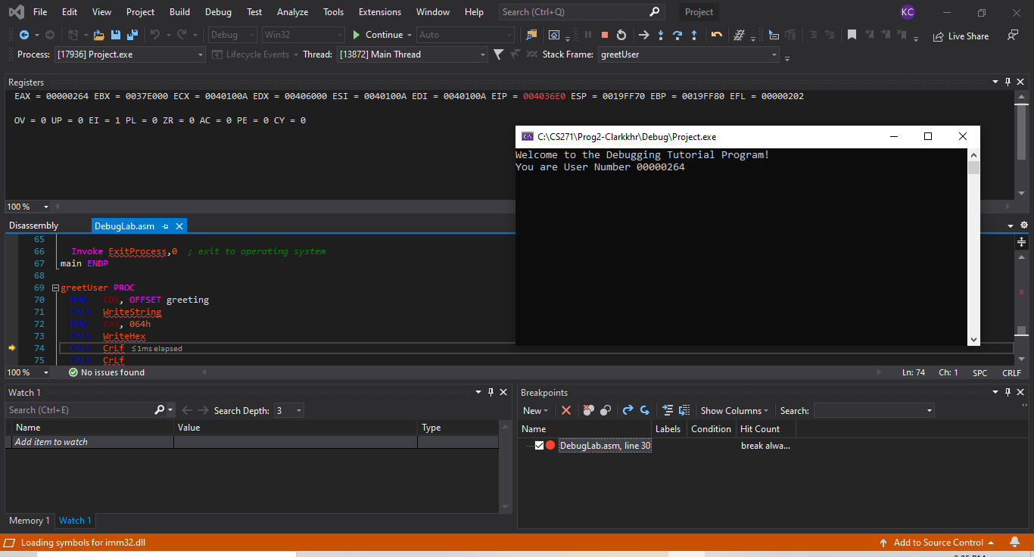

Part 3:

1. After completing Step 13, what is the memory address (in the code segment) of the **_validName** code label?
   * 00406377 (Circled number to the left in the Disassembly screen)
2. What instruction (with operands), if any, is stored at the code segment address from Question 1 above?
   * 39: JNE _validName *; Filename Checks Out! (Circles line of code in the disassembly screen)*  
     In addition to writing the instruction (with operands) if any, please circle this line on the screenshot attached to this part in your report, including the address from Question 1.
3. What is the **significance** of the relationship between the value in EIP (in the Registers window) and the leftmost value on any given line?
   * The EIP refers to the next register to run and the left most value is usually the EIP to be initiated in that line of code. (the circled portion in the registers screen/tab)

Instructor Feedback: 403677 is the address of the instruction JNE _validName. However, the question asks for the address of the instruction indicated by the code LABEL _validName, which is 040368Ah

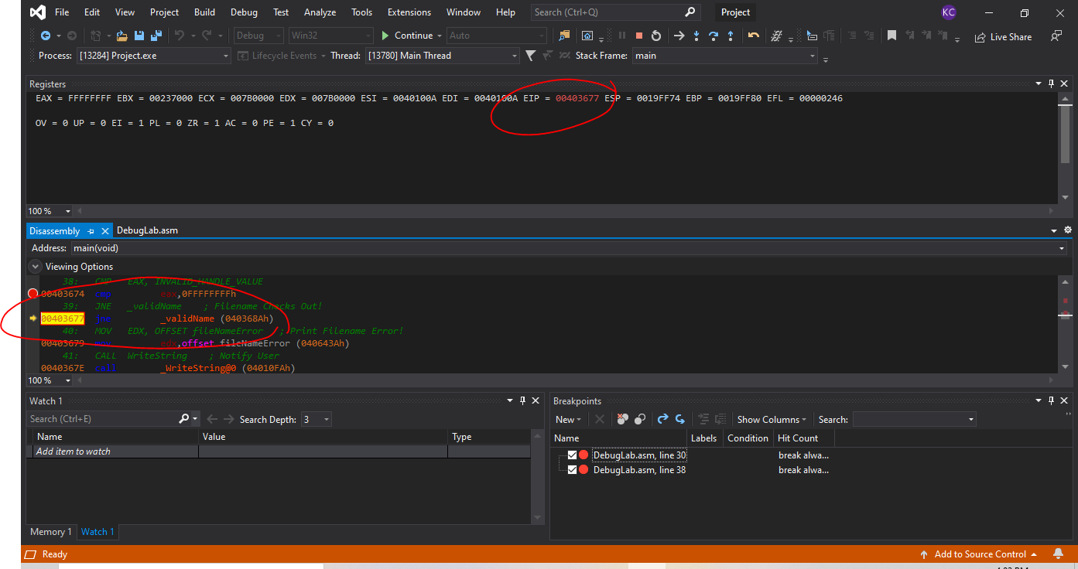

Part 4:

1. What is the (n+1)st byte (index n) of TestText.txt, where n = (the last three digits of your ONID ID number)?
   * The letter “a” in “The mutiny was”. (n=264)
2. Remember to take a screenshot of the Memory window used to collect this information for inclusion in the lab report. Please circle the value in the address bar and the character in the ASCII portion of the Memory debug window.

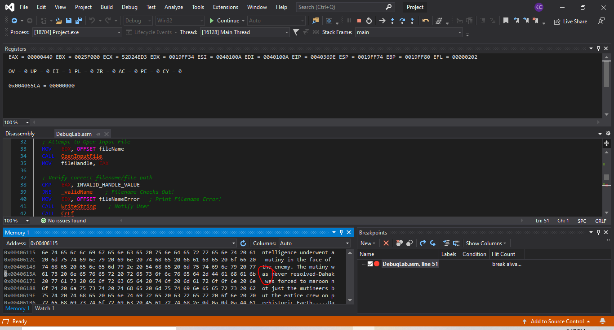

Part 5:

1. What is the unsigned value of **fileHandle** after opening the TestText.txt file?
   * 248 or hex=0x000000f8  
     Remember to include a screenshot that shows where you obtained this information, and please circle the value of **fileHandle**on this screenshot.

